[Pick the date] | 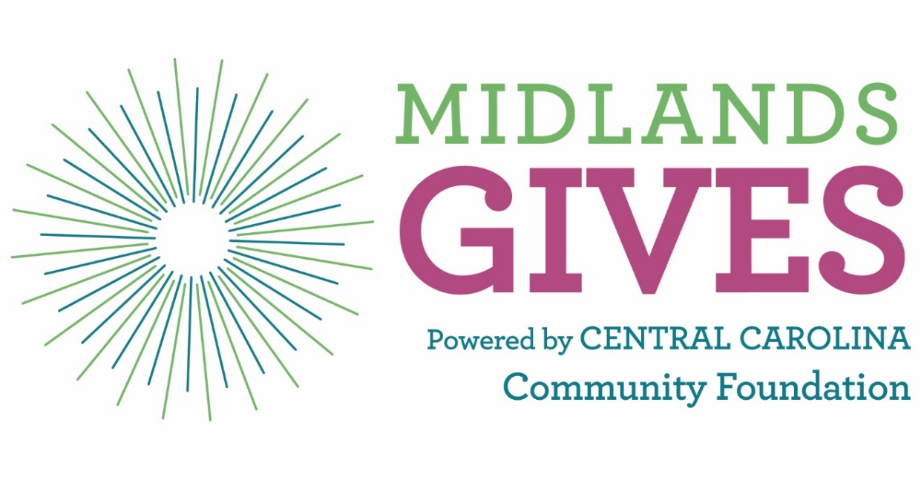
 | 8 Week Workplan for a Successful May 1st!
An interactive workbook to help you create, plan and implement your
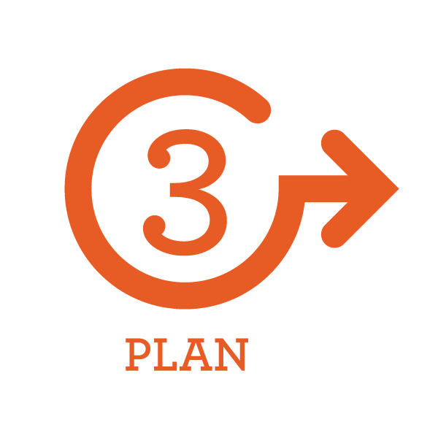
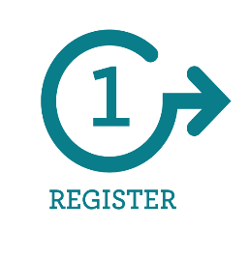
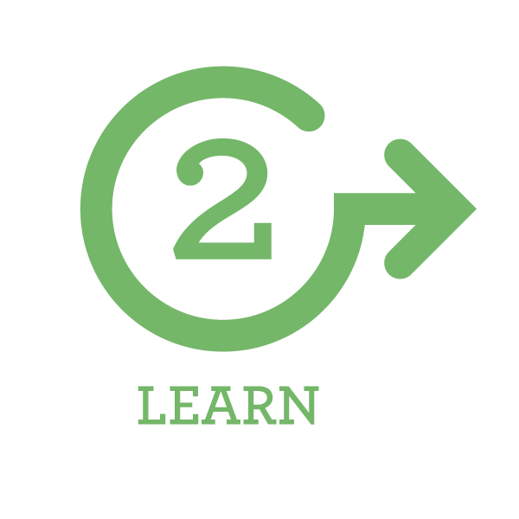
8 week Midlands Gives campaign

Getting Started: Planning
Planning is the most important aspect of a successful campaign. Before you dive in, take a moment to answer these questions and get your plan of attack in order.
- Evaluate your performance from previous year (if applicable)
  - What did we do well?
  - What tweaks should we make?
  - Look at last year’s donor data- know your donors and their behavior
- How much money do I want to raise? How many donors engaged?
- What other goals do I want to set? Some examples are increased visibility, capacity in social media, stronger board/staff alignment, new donors, increased knowledge in fundraising, new partnerships, etc.
- Do I have a current list of active donors and their contact information? Is it compiled in an easily accessible location? (spreadsheet, database?)
- Will my campaign attempt to:
  - Raise a pool of matching funds
  - Compete for a prize challenge
  - Use social media
  - Have an event
  - Collaborate with another nonprofit
  - Partner with a business

Getting Started: Goal Setting
Goals for the Midlands Gives are more than financial. Manage your expectations for setting your overall philanthropic goals: new donors, visibility, marketing, social media.
- What is your financial goal for Midlands Gives?
_________________________________________________________________________________________________________________________________________________________________________________________________________________________________
- What is your donor goal?
_________________________________________________________________________________________________________________________________________________________________________________________________________________________________
- What other goals do you have?
_________________________________________________________________________________________________________________________________________________________________________________________________________________________________
- What is your plan to secure a matching gift? How much do you want to raise?
_________________________________________________________________________________________________________________________________________________________________________________________________________________________________
- How do you plan on measuring these goals?
_________________________________________________________________________________________________________________________________________________________________________________________________________________________________
- What tools/resources/staff do you need to implement this practice?
_________________________________________________________________________________________________________________________________________________________________________________________________________________________________
Notes: __________________________________________________________________________________________________________________________________________________________________________________________________________________________________________________________________________________________________________________________________________________________________________________________________________________________________________________________________
Best Practice #1: Board Engagement
Board participation is a crucial element for success on May 1st. How will you engage your board and activate them to assist with your Midlands Gives campaign?
- What will be your goal for board giving? (100%, increase from last year, etc.)
_______________________________________________________________________________________________________________________________________________________________________________________________________________
- What prize challenges will you and your board work on together? (Prizes will be announced Feb. 2018)
_______________________________________________________________________________________________________________________________________________________________________________________________________________
- What donor engagement strategies will your board employ?
_______________________________________________________________________________________________________________________________________________________________________________________________________________
- What social media activities will you ask of your board?
_______________________________________________________________________________________________________________________________________________________________________________________________________________
- What other communication/marketing activities will your board engage in?
_______________________________________________________________________________________________________________________________________________________________________________________________________________
- What other tasks or strategies will you ask your board to participate in?
_______________________________________________________________________________________________________________________________________________________________________________________________________________

Notes: __________________________________________________________________________________________________________________________________________
Best Practice #2: Donor Engagement
Engaging your donors before, during and after Midlands Gives drives home the importance of donor stewardship, cultivation and keeping them aligned with your organization for continued engagement, support and gifts.
- How will you engage your current donor base?
_______________________________________________________________________________________________________________________________________________________________________________________________________________
- How will you thank your donors during May 1?
_______________________________________________________________________________________________________________________________________________________________________________________________________________
- What is your plan to thank your donors after May 1?
_______________________________________________________________________________________________________________________________________________________________________________________________________________
- How will you engage new donors?
_______________________________________________________________________________________________________________________________________________________________________________________________________________
- What tools/resources do you need to implement this practice?
_______________________________________________________________________________________________________________________________________________________________________________________________________________
Notes:
__________________________________________________________________________________________________________________________________________________________________________________________________________________________________________________________________________________________________________________________________________________________________________________________________________________________________________________________________________________________________
Best Practice #3: Know Your Audience

To craft the right and most effective message, you need to know your audience. Who are they? How can you find them and how can they be your best ambassadors?

- Who are your current audiences?
_______________________________________________________________________________________________________________________________________________________________________________________________________________
- Who do you want to target? (prioritize them)
_______________________________________________________________________________________________________________________________________________________________________________________________________________
- How will you reach them?
_______________________________________________________________________________________________________________________________________________________________________________________________________________
- Your Message: How is the world different because you exist? What stories of impact can you share?
_______________________________________________________________________________________________________________________________________________________________________________________________________________
- What tools/resources do you need to prepare and develop to implement this practice?
_______________________________________________________________________________________________________________________________________________________________________________________________________________
Notes:
____________________________________________________________________________________________________________________________________________________________________________________________________________________________________________________________________________________

Best Practice #4: Messaging/Storytelling

The story you tell will be the most important aspect of your marketing strategy. Here are a few tips and questions to ask yourself as you begin to craft your messaging:

- Talking about your impact and not the need is one way to capture your audience. How is your organization working to change for the better? Solutions, not problems will attract more attention and help to hone your narrative.
- Visuals (graphics, photos, videos) can be a very potent aid in getting your message across in a short amount of time. Think about what visuals could help represent your story and your organization’s impact.

- How is your organization’s story unique from other organizations with similar missions and services?
_______________________________________________________________________________________________________________________________________________________________________________________________________________

- How does your organization make an impact on our community? Are there individual stories of success you can share?
_______________________________________________________________________________________________________________________________________________________________________________________________________________

- Will your Midlands Gives campaign and messaging center around a specific program, purpose or theme?
_______________________________________________________________________________________________________________________________________________________________________________________________________________

- What communication tools will you use to tell your story? Consider tools your organization already uses and how you may want to incorporate them.
_______________________________________________________________________________________________________________________________________________________________________________________________________________

Best Practice #5: Social Media
For an online event, social media plays a huge role. Even if you are new to this way of communicating, Midlands Gives is the time to dive in and get your feet wet! Utilizing Facebook and other platforms will help you communicate to your current and future donors pre-event, during and long after the event.
- What social media platforms will you use for Midlands Gives?
_______________________________________________________________________________________________________________________________________________________________________________________________________________
- What are the key messages you will convey on these platforms?
_______________________________________________________________________________________________________________________________________________________________________________________________________________
- How will you use social media to promote your prize challenges strategy?
_______________________________________________________________________________________________________________________________________________________________________________________________________________
- Do you have a staffing plan? Who will run your social media campaign?
_______________________________________________________________________________________________________________________________________________________________________________________________________________
- What other tools/resources do you need to implement this practice?
_______________________________________________________________________________________________________________________________________________________________________________________________________________
Notes:
___________________________________________________________________________________________________________________________________________________________________________________________________________________________________________________________________________________________________________________________________________________________________________________________________________________________________________________________________________________________________
Develop and Execute Your Plan
Using your notes from the best practices, you are now ready to put it all together. Use the template below to create your 8-week workplan.
Keep in mind that the first 4 weeks of your plan should be dedicated to planning and preparation. The 2nd half of your plan should be implementing, starting with soft marketing, then transitioning into heavy marketing at the 2 week mark.

Our Midlands Gives Goals:
Dollar Goal: ____________________
Donor Goal: ______________
New Donor Goal: __________________
Matching Gift Goal: ________________

We will compete for the following prize challenges:
______________________________________________________________________________________
______________________________________________________________________________________
______________________________________________________________________________________
Other goals:
______________________________________________________________________________________
______________________________________________________________________________________
______________________________________________________________________________________
______________________________________________________________________________________
What is your plan to accomplish these goals?
______________________________________________________________________________________
______________________________________________________________________________________
______________________________________________________________________________________
______________________________________________________________________________________
______________________________________________________________________________________
______________________________________________________________________________________

Timeline
The power of a 24-hour giving day is the sense of urgency it creates for donors to act within a short amount of time. Oversaturation and fatigue are real factors to consider, which is why Midlands Gives’ work plans and check lists work on an 8- week plan.
- Weeks 1-4: Planning and Preparations
- Weeks 5-8: Marketing and Execution

In addition to the 8-week plan, your marketing timeframe should also be broken up into two sections:
- The first two weeks of April we call “soft marketing,” which means a light approach:
  - Casual/indirect communications
  - Save the dates
  - Inserted info in already scheduled correspondence
  - Invites to events
  - Light social media
- The two weeks prior to May 1st is the “heavy marketing” period and includes:
  - Direct call-to-action communications
  - Heavy social media
  - Printed items drop
  - Scheduled emails
1 | 2 | 3 | 4 | 5 | 6 | 7
8 | 9 | 10 | 11 | 12 | 13 | 14
15 | 16 | 17 | 18 | 19 | 20 | 21
22 | 23 | 24 | 25 | 26 | 27 | 28
29 | 30 | 1

SOFT MARKETING

HARD MARKETING

Roles
Now that you have some idea of what you’d like to achieve by May 1st, it is time to think about the tasks that need to get done and who you have on your team to help you complete those tasks. Whether it is a volunteer, a board member, or paid staff, it’s time to think about assembling your team.

Role | Tasks | Name of staff/volunteer
Midlands Gives Lead Contact(s) | Project manager, attend trainings, maintain profile, and communicate with Midlands Gives team as needed.
Social Media | Schedule posts, create graphics, monitor accounts, interact, etc.
Email Marketing
Donor Engagement
Board Engagement
Event Coordinator
Website/CiviCore

Day-of Team

Week Eight (March 5-9) Meet, Plan, Discuss
Checklist:
___ Set weekly meetings with your staff or volunteers who will be assisting with your campaign
___ Make sure you have completed filling out your plan
___ If you are creating special printed materials, decide what those will be and begin design & production
___ Decide on what and how many prize challenges you will attempt to win
___ Finalize donor email/contact lists and make sure all information is ready to use
___ Create outreach strategy for current donors
 | Task | Staff | Status | Notes
Planning
Communication
Donor Engagement
Board Engagement

Week Seven (March 12-16) Teasers and Preparations
Checklist:
___ Download all items from the Nonprofit Marketing Toolkit at www.midlandsgives.org
___ Begin outreach to local businesses to form partnerships and support
___ Add a teaser or save the date block to your website and outgoing e-newsletters
___ Midlands Gives updates at your monthly or quarterly board meeting
___ Create target list of asks for matching gifts
___ Make sure you have completed all checklist items from the previous week!
 | Task | Staff | Status | Notes
Planning
Communication
Donors
Board
Other

Week Six (March 19-23) Preparing for Your Soft Marketing Launch
Checklist:
___ Decide on communication tools
___ Determine who will run your social media campaign (staff, hired consultant, volunteer, etc.)
___ Decide if your organization will attend or host an event on May 1st
___ Reach out to other NPOs in your sector and see if there are some ways you can collaborate
___ Begin making asks for matching gifts
___ Create staffing plan for May 1st
 | Task | Staff | Status | Notes
Planning
Communication
Donor Engagement
Board Engagement
Other
Week Five (March 26-30) Soft Marketing Launch
Checklist:
___ If you are using printed materials, drop them in the mail no later than next week (NPO bulk mail takes about 10 days)
___ Work on your “thank you” plan for donors for day-of and post-May 1st
___ Do a check and make sure you have completed all previous checklist steps
___ Implement current donor outreach plan
 | Task | Staff | Status | Notes
Planning
Communications
Donor Engagement
Board Engagement
Other

Week Four (April 2-5) Continue Soft Marketing
Checklist:
___ Create board task list and assign to members
___ Send invites to day-of events (if having one)
___ Schedule key meetings with donors (pre-commitments)
___ Begin talking about your involvement in Midlands Gives at meetings and events. Bring postcards with you and leave in office lobbies, coffee shops, etc.
___ Continue to implement your communications plan (emails, social media, etc.)
 | Task | Staff | Status | Notes
Planning
Communications

Donor Engagement
Board Engagement
Other

Week Three (April 9-13) Prepare for 2-week Marketing Blitz
Checklist:
___ Create email blasts and schedule of releases
___ Finalize social media schedule and content
___ Finalize partnerships with businesses and other nonprofits
 | Task | Staff | Status | Notes
Planning
Communications
Donor Engagement
Board Engagement
Other

Week Two (April 16-20) 2-week Heavy Marketing Begins
Checklist:
___ Amp up social media posts – add Midlands Gives graphics to Facebook and Twitter
___ Begin sending emails
___ Make targeted phone calls to donors telling them about the event
___ Finalize day-of roles and staffing plan
 | Task | Staff | Status | Notes
Planning
Communications
Donor Engagement
Board Engagement
Other

Week One (April 23-27) Heavy Marketing Continues
Checklist:
___ Make sure you know how to view your donor data through the CiviCore site
___ Continue heavy social media presence
___ Remind board of roles (outreach, sending emails, etc.)
___ Finalize day-of event plans
___ Schedule social media posts for May 1st
___ Prepare your own website to have Midlands Gives on the front page and direct donors to your donation page on midlandsgives.org, including changing the link on your donate now button.
 | Task | Staff | Status | Notes
Planning
Communications
Donor Engagement
Board Engagement
Other

May 1st – MIDLANDS GIVES!
Checklist:
___ Kick off at midnight with a bang! Ask board members to help kick off your campaign by donating at midnight.
___ Pound the pavement! Get out into the community. Attend events
___ Check in with all board members and make sure they are ready to implement your plan.
___ Be active all day on social media
___ Check your donor data every hour and make sure you are thanking donors in real time either on social media or email.
 | Task | Staff | Status | Notes
Communications
Donor Engagement
Board Engagement
Other
Post Midlands Gives – Day After and Beyond!
Checklist:
___ Get some rest!
___ Download donor data and add it to your mailing and email lists
___ Continue your plan of thanking all donors
___ Implement donor thank you plans. (i.e. who will receive calls, send personal letters, thank you cards, emails, etc. (check your staff role list)
___ Send thank you’s to businesses and other NPOs you partnered with
___ Send an update to your board, staff, volunteers, networks and donors list on your results!
__ Develop plan to continue to engage and communicate with new donors
 | Task | Staff | Status | Notes
Communications
Donor Engagement
Board Engagement
Other
Tips for Success
There are a hundred and one things you can do with your Midlands Gives fundraising campaign. We hope you have found some inspiration through taking yourself through this work plan! As you are preparing and planning, here are a few extra tips to help you along the way:
Attend Midlands Gives Webinars: These sessions will keep you informed and up-to-date on the latest updates on website functions, prizes, and other items. It will also provide you the opportunity to ask questions to the organizers. These webinars take place once a month.
Mixer Events: The Foundation will host networking events leading up to Midlands Gives for you to meet and connect with fellow nonprofit participants. This is a great opportunity for you to join forces with another organization.
Prize Challenges: These will be announced during the February Midlands Gives webinar. Think about if it makes sense to attempt to win one and how you can message these prizes to donors to boost your messaging!
Facebook Learning Community Group: Want advice or to ask a question to your peers? Looking to connect or have fun with Midlands Gives related issues? If you have a personal Facebook account, log in and in the search bar enter “Midlands Gives NPO Learning Exchange” and ask to join. This is a closed group created specifically for nonprofit participants.
Meet With Your Mentor: If you were assigned a mentor this year, make sure to connect with them at least once or twice! This is a golden opportunity for some one-on-one technical assistance with the pros.
Use the Website: Midlandsgives.org has a lot of information for you to use: Rules and FAQs, Toolkit with graphics and template, listing of the prizes and challenges and much more.
Thank Your Donors in REAL TIME: You will be able to log in to your CiviCore account to access your donor information on the day of giving! Along with your marketing efforts, it should be #1 on your list of to-dos for May 1st.
Partner with a Business: Find a coffee shop, restaurant or other business that can help you. Businesses can help by using their own social media accounts, host an event, provide kick-backs to purchases, and more.
Secure Matching Funds: Matching funds are funds you raise before the day of giving on your own that you can advertise on the day! Donors love to know that their dollars will be amplified by donating to you.

