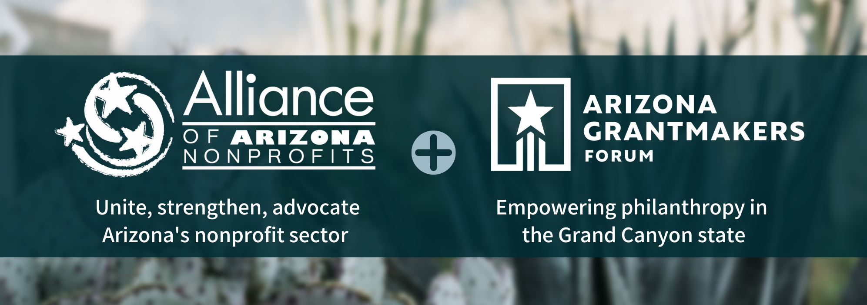
NEWS RELEASE

FOR IMMEDIATE RELEASE

EARLY REGISTRATION AND RE-ENROLLMENT OPENS NOV. 1 FOR NONPROFITS PARTICIPATING IN 2023 ARIZONA GIVES DAY, PRESENTED BY FIRSTBANK
Arizona Gives Day Has Raised $36.4 Million for Arizona Nonprofits Since 2013

PHOENIX, Ariz. (Oct. 19, 2022) –Registration and re-enrollment will open November 1 for Arizona nonprofits interested in participating in the 24-hour online fundraising event, from 12 a.m. to 11:59 p.m. on April 4, 2023.

Since 2013, Arizona Gives Day has raised more than $36 million for nonprofits statewide. The event in 2022 generated more than $6 million in addition to pledges of 36,269 volunteer hours by 955 volunteers.

Presented by FirstBank, one of the nation’s largest privately held banks with a focus on “banking for good,” Arizona Gives Day is hosted by the Alliance of Arizona Nonprofits, which merged with Arizona Grantmakers Forum this past August.

Arizona Gives Day unites nonprofits, big and small, new and established, to celebrate and increase philanthropy in Arizona through online giving. Arizona Gives Day helps raise awareness about the critical role Arizona nonprofits play in our communities and inspires people to give generously to create a thriving and stronger Arizona for all.

Re-enrollment and payment of a refundable registration fee is required annually and can be completed at www.AzGives.org beginning November 1. “Early bird” registration, through January 31, 2023, is the best value for new or re-enrolling organizations. The registration deadline for registration is February 28, 2023. Registrants receive access to workshops and training and the Giving Day marketing toolkit.

Early Bird registration refundable deposit fee is $50. Fees after Jan. 31 increase to $75. Registration fees from Feb. 21-28 include a $25 late fee for a total of $100.

Information required for registration and re-enrollment includes general information about the nonprofit; IRS Determination Letter; the most-current completed financials through Form 990 or the organization’s operating budget; and a bank account and routing number for electronic distribution of donations.

Arizona Gives virtual workshops to assist in making each participant’s fundraising experience a success will take place at several intervals before AZ Gives Day. Registrants can participate in real time or view the recording at a later date.

Changes for the 2023 campaign include:
- Addition of Google Pay and Apple Pay for donor payment
- A new “Repeat Your Donation” email reminder for past donors
- Integration of the donor fundraiser page functionalities with one’s donor donation account; donors will have just one log-in now
- Giving Day campaign peer learning and sharing options

For interested donors, AzGives.org offers an advanced search filter to find nonprofits by specific criteria, area of focus, and which donations may qualify as an Arizona tax credit. Donors also can create an account to set up recurring donations allowing them to make changes to their giving throughout the year, track their donations and create a fundraiser page for their favorite nonprofit.

Complete information including answers to important questions about Arizona Gives Day can be found at www.AZGives.org.

Contacts: • Jennifer Purcell, jenniferp@arizonanonprofits.org, (602) 279-9166 • Kate Crowley, Crowley Communications, (480) 277-4178 • Steve Carr, The Kur Carr Group, Inc., (602) 317-3040

About the Alliance of Arizona Nonprofits: The Alliance of Arizona Nonprofits is a trusted statewide resource and advocate for the state’s nonprofit and philanthropy communities following the merger with Arizona Grantmakers Forum in August 2022. The merged organization leverages the combined strengths of two important, credible and respected statewide associations to maximize value for members and advance the sector through more effective collaborations. The Alliance’s mission is to unite, strengthen and advance Arizona’s nonprofit and philanthropic sectors, and it is comprised of more than 1,100 members – both nonprofits and those in the community who support them – across the state. Since 2004, the organization has been dedicated to an Arizona where all nonprofits are valued, empowered and thriving, with support from grassroots efforts like Arizona Gives. For more information, visit www.arizonanonprofits.org or email info@arizonanonprofits.org.

