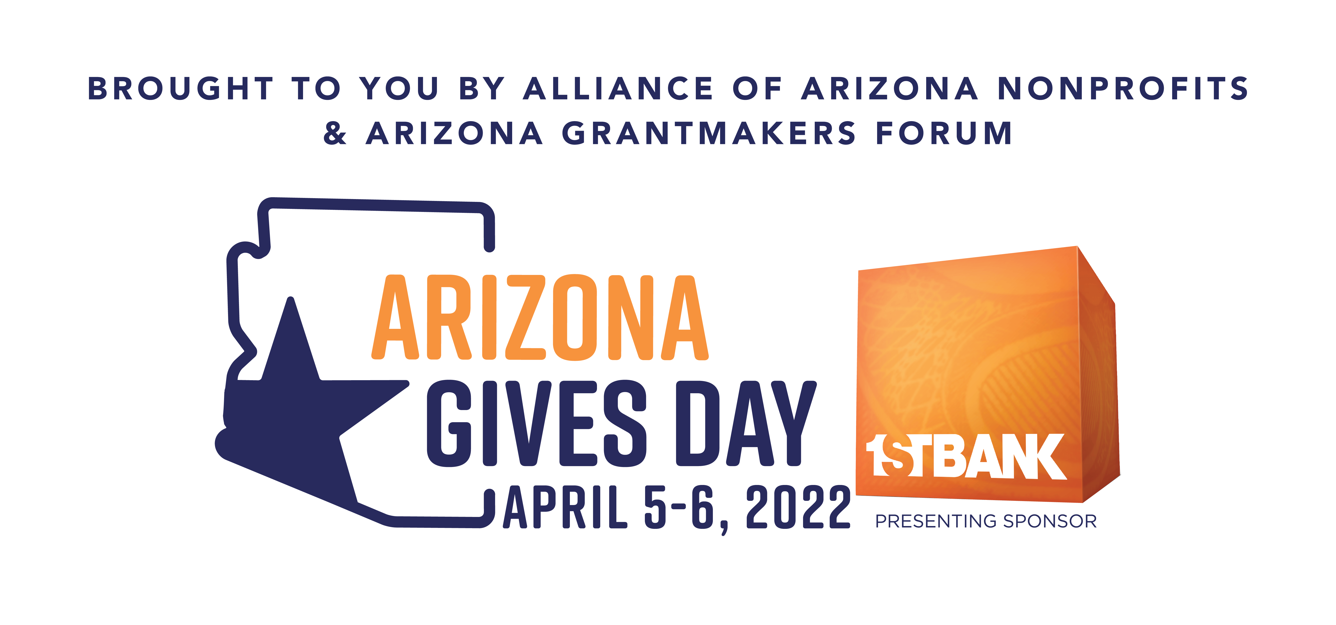

NEWS RELEASE

FOR IMMEDIATE RELEASE

2022 ARIZONA GIVES DAY RAISES $6 MILLION FROM 32,068 DONATIONS FOR NEARLY 1,000 NONPROFITS ACROSS THE STATE

PHOENIX, Ariz. (May 13, 2022): Arizona Gives Day 2022 raised more than $6 million for nearly 1,000 nonprofit organizations across the state during the 24-hour fundraising event in April.
More than 32,000 donations were made to 918 of the 1006 participating nonprofits to bring the grand total raised since the event began in 2013 to $36,406,062. The average amount of money raised per organization was $6,546 with the average online donation at $239.
Also during the event, 955 volunteers pledged a total of 36,269 hours to their favorite nonprofit organizations.
Nonprofits also had the opportunity to win one of 116 cash incentive prizes. The complete list of results can be found at www.AZGives.org/prizes.
The final numbers for the year event, organized by the Alliance of Arizona Nonprofits and Arizona Grantmakers Forum and presented by FirstBank, one of the nation’s largest privately held banks with a focus on “banking for good,” include prize pool distributions of more than $180,000 and from additional donations that came in after the 24-hour online fundraiser had ended.
“Heading into this year’s event, given the nature of the economy, the global unrest and the fact that we were just climbing out of the pandemic, we weren’t sure where Arizona Gives Day would end up,” said Alliance of Arizona Nonprofits CEO Kristen Merrifield. “The results certainly show that the people of Arizona are more than willing to generously step up to support the incredibly important work being done by nonprofits in every community in our state. On behalf of those nonprofits, we are deeply grateful.”
Top Arizona Gives Day Prize Pool winners were: $6,500 - Harvest Compassion Centers, Phoenix; Basis Charter Schools, Scottsdale; No More Deaths/No Mas Muertes, Tucson; Pawsitively Cats, Inc., Tucson; $4,500 - Forever Loved Pet Sanctuary, Scottsdale; Phoenix Rescue Mission, Phoenix; Hoofsnhorns Farm Sanctuary, Tucson; Friends of PACC (Pima Animal Care Center), Tucson; $4,000 - Northern Arizona Pioneers’ Historical Society, Flagstaff; Catalina Foothills School Band Boosters, Tucson; Tucson Arizona Boys Chorus, Tucson; Make Way for Books, Tucson; Southwest Oasis Labrador Rescue, Tucson; GAP Ministries, Tucson; $2,500 - Northland Pioneer College Friends and Family, Inc., Snowflake; Rescue Me Tucson, Tucson; Ironwood Tree Experience, Tucson; Ironwood Pig Sanctuary, Tucson; Community Food Bank of Southern Arizona, Tucson; $2,000 - Grand Canyon Wolf Recovery Project, Flagstaff; Rusty’s Angels Sanctuary, Phoenix; Arizona Cattle Dog Rescue, Carefree; United Food Bank, Mesa; Desert Labrador Retriever Rescue, Glendale; Southern Arizona Greyhound Adoption Tucson; Ben’s Bells, Tucson; Hearts That Purr Feline Guardians, Tucson; Humane Society of Southern Arizona, Tucson; Miracle Center, Tucson; Fox Tucson Theater Foundation, Tucson.
Donations can be made to Arizona nonprofits all year long by visiting www.AzGives.Org, AZGives.org offers an advanced search filter to find nonprofits by specific criteria, area of focus, and which donations may qualify as an Arizona tax credit. Donors can either check out as a guest or create an account to set up recurring donations and make changes to their giving throughout the year.
Arizona Gives Day is not possible without the support of its sponsors and promotional partners: FirstBank, Arizona Community Foundation, BHHS Legacy Foundation, Freeport McMoRan Foundation, Frontdoors Media-Home of The Red Book, Hickey Family Foundation, InBusiness Greater Phoenix Magazine, PHOENIX Magazine, Thunderbirds Charities, Vitalyst Health Foundation, Community Foundation of Southern Arizona, Intel Corporation, Salt River Project (SRP), Southwest Gas Corporation, SechlerMorgan CPA and Tucson Electric Power/UniSource Energy Services.

ARIZONA GIVES DAY 2022 FAST FACTS
- 1006 nonprofits participated from across the state
- 32,068 donations totaling $6,009,701
- 955 volunteers pledged 36,269 hours.
- Total amount raised since 2013: $36,406,062
- Giving can be done all year at AZGives.org where you can choose one or more organizations for your donation or find new Arizona organizations to give to.

- Giving eCards can be purchased all year at www.azgives.org/ecards. The person receiving the eCard gets to choose which nonprofit to donate to.

For more information about Arizona Gives Day, visit www.AzGives.org. For more information about the Alliance of Arizona Nonprofits, go to www.arizonanonprofits.org.
For more information about FirstBank, visit www.efirstbank.com. For more information about Arizona Grantmakers Forum, go to www.arizonagrantmakersforum.org.
-30-
Contacts:
• Jennifer Purcell, Senior Vice President & Director of Development, Alliance of Arizona Nonprofits, jenniferp@arizonanonprofits.org, (602) 279-9166
• Kate Crowley, Crowley Communications, kate@crowleycommunications.com, (480) 277-4178
• Steve Carr, The Kur Carr Group, Inc., scarr51@gmail.com, (602) 317-3040

About the Alliance of Arizona Nonprofits: The Alliance of Arizona Nonprofits is a statewide trusted resource and advocate for the nonprofit community. The Alliance’s mission is to unite, strengthen and advance Arizona’s nonprofit sector and is comprised of more than 1,000 members – both nonprofits and those in the community who support them – across the state. Since 2004, the organization has been dedicated to furthering the common interests of Arizona’s nonprofit community and envisions an Arizona where all nonprofits are valued, empowered and thriving, with support from grassroots efforts like Arizona Gives Day. For more information, visit www.arizonanonprofits.org, or email azgives@arizonanonprofits.org.

About FirstBank: FirstBank began providing banking services in Colorado in 1963. Today, the bank maintains more than $23 billion in assets and operates more than 110 branch locations across Colorado, Arizona and California. FirstBank offers a variety of checking accounts, savings accounts, home equity loans, mortgages, and a full range of commercial banking services, including financing, treasury management and deposit accounts. Since 2000, FirstBank has been recognized as a leader in corporate philanthropy, contributing nearly $70 million and thousands of volunteer hours to charitable organizations. The company is also unique in that a large portion of its stock is owned by management and employees, giving employees a financial stake in the bank’s success through its Employee Stock Ownership Program. For more information, visit www.efirstbank.com. MEMBER FDIC

About the Arizona Grantmakers Forum: Arizona Grantmakers Forum is the statewide network that connects, educates and advocates for Arizona philanthropy. With a mission to empower its members to transform Arizona through leadership and meaningful philanthropy, Arizona Grantmakers is made of organizations that provide funds and resources to nonprofit organizations throughout the state. Members include private foundations, trusts, endowed community foundations, corporate foundations, businesses with charitable giving programs, government agencies and individuals with organized giving programs. For more information, visit www.arizonagrantmakersforum.org.

